DBMS

LAB ASSIGNMENT - 2



Ananya Agarwal

102083036

2CO14

1. Create table emp which has the following attributes (empno, ename, job, sal, deptno)

Code:

create table emp(empno number, ename varchar2(20),job varchar2(20), sal float, commission float, deptno number)

E:\4th sem\DBMS\lab\ass\ass sol2\1.PNG

1. Insert appropriate records in above tables.

Code:

insert into emp values(1,'Raj','Salesperson',20000,500,10);

insert into emp values(2,'Sham','Clerk',35000,1000,20);

insert into emp values(3,'abhivansh','CEO',120000,15000,5);

insert into emp values(4,'Ram','Manager',90000,9000,15);

insert into emp values(5,'Ananya','Assistant Manager',80000,7000,7);

insert into emp values(6,'ABHIMANYU','Director',100000,12000,74);

insert into emp values(7,'ayaan','Coordinator',95000,10000,21);

insert into emp values(7,'AANYAA','Coordinator',95000,null,21);

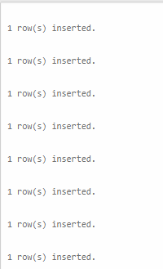

1. Get employee no and employee name who works in dept no 10

Code:

select empno,ename from emp where deptno=10;

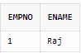

1. Display the employee names of those clerks whose salary > 2000

Code:

select ename from emp where sal > 2000 and job='Clerk';

E:\4th sem\DBMS\lab\ass\ass sol2\4.PNG

1. Display name and sal of Salesperson & Clerks

Code:

select ename,sal from emp where job in ('Clerk','Salesperson');

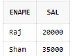

1. Display all details of employees whose salary between 2000 and 3000

Code:

select * from emp where sal between 2000 and 3000;

E:\4th sem\DBMS\lab\ass\ass sol2\6.PNG

1. Display all details of employees whose dept no is 10, 20, or 30

Code:

select * from emp where deptno in (10, 20, 30);

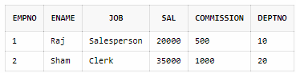

1. Display name of those employees whose commission is NULL

Code:

select * from emp where commission is null;

E:\4th sem\DBMS\lab\ass\ass sol2\8.PNG

1. Display dept no & salary in ascending order of dept no and with in each dept no salary should be in descending order

Code:

select deptno,sal from emp order by deptno,sal desc;

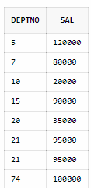

1. Display name of employees that starts with ‘C’

Code:

insert into emp values(8,'Chaitanya','HOD',500000,200,1);

select ename from emp where ename like 'C%';

E:\4th sem\DBMS\lab\ass\ass sol2\10.PNG

1. Display name of employees that ends with ‘C’

Code:

insert into emp values(8,'ABC','clerk',10000,400,15);

select ename from emp where ename like '%C';

E:\4th sem\DBMS\lab\ass\ass sol2\11.PNG

1. Display name of employees having two ‘a’ or ‘A’ chars in the name

Code:

select ename from emp where (length(ename))-length(replace((ename),'a',''))=2 or (length(ename))-length(replace((ename),'A',''))=2;

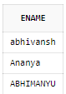

1. Display the name of the employees whose second char is ‘b’ or ‘B’

Code:

select ename from emp where ename like '_b%' or ename like '_B%';

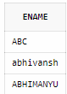

1. Display the name of the employees whose first or last char is ‘a’ or ‘A

Code:

select ename from emp where lower(ename) like 'a%' or lower(ename) like '%a';

